**“Use of Modern Techniques to improve boiling house efficiency” \***

**By;- Sanaullah\*\***

**Introduction:-**

As we have entered the 21st century, the sugar industry found itself at a cross road facing many difficult challenges and opportunities: cost of production, soaring energy cost, environmental pressure, health and safety issues, regulatory compliance, global competition (WTO); and a global economy in which the only **Constant** is “**change**”.

To survive and prosper in this new millennium, the conventional wisdom of industrial strategies, characterized by emphasis in risk management, centered in downsizing, restructuring, reengineering and implementation of automation and information technology, are mostly completed in the western world. However, Pakistani sugar industry, comparing to the western sugar industries as a whole, has not kept pace with needed progress and change. We must implement a sustainable process with minimal production cost. We must address the process of managing talent, develop, adopting the latest technology, provide and strengthen positive culture, creating a sense of urgency, describing a winning future.

Considering the theme of the Workshop we will confine our discussion to only “Improving Boiling House Efficiency by Adopting Modern Techniques”.

Any reduction of sugar loss in boiling house improves the boiling house efficiency. There are many controlling factors which affect it;

1. Equipment Design.
2. Automation.
3. Skill of manpower.
4. Process controlling scheme.
5. Quality of Sugar cane.
6. Prevailing economic forces and trends.
7. Capacity utilization of process.

**\* Presented at Technical Workshop of PSST, 2012, hotel PC, karachi**

**\*\* Deputy General Manager (P), Mehran Sugar Mills Limited, Tandoallahyar.**

We will discuss topics mentioned at Sr # 1 & 2, considering the theme of the Workshop.

Before formal discussion; take a look at Chemical Losses;

**Chemical Loss**

1. Sucrose molecule is most stable between pH of 7.8 – 8.2.
2. The sucrose inversion rate increase by 900% when pH is dropped from 7.5 to 6.5.
3. The sucrose inversion rate increase by 300% for each 10° C in temperature.
4. Rate of sucrose inversion rate increase 100% when density is reduced from 60 brix to 10 brix.
5. Invert in sugar solution accelerates sucrose destruction.
6. The rate of inversion increases with decreasing purity and density.

**Equipment Design:-**

World sugar industry is reaping the fruit of technological improvement; whereas Pakistani sugar industry is much reluctant for adopting the new technological advancement. We should be progressive in this regard; otherwise there will be no place for us in the international market. Following are the major areas of equipment’s technological development;

1. Tubular heaters are being replaced by more efficient plate type and direct contact juice heaters. Compact design means less danger of inversion.
2. CFD (computational fluid dynamics) has greatly improved the design of SRI juice clarifier. Retention time has even reduced to below 30 minutes, which definitely reduces inversion losses.
3. Use of small aperture Contra-shear screens at juice clarifier.
4. Early open pan evaporation converted to Robert type of evaporator for improving thermal efficiency and sugar loss. Now, for three decades, Robert type evaporators, which have served a long time for sugar industry, are being replaced by “Falling Film Tubular/Plate evaporators”. This development, however initiated for conservation of energy, also contributes a lot for decreasing sugar losses and color formation across the evaporators. Any reduction in color formation reduces the color load from refinery, means less recirculation of sugar for achieving desired color and thus less sugar losses.
5. Continuous pan has already proved their significance.
6. CFD has improved the design of Vertical Crystallizer. The new development is vertically, up & down, moving coils with the help of hydraulic. This design ensures better heat transfer and massecuite flow pattern.
7. Use of jigger steam in batch pan. We will discuss this topic in detail;

**Jigger steam in a Batch Pan:**

Jigger steam is a common and important feature of a conti pan. Its use in batch pan has proved benefit for better massecuite circulation, whether pan has or has not equipped with mechanical circulator. In the batch pan a perforated pipe, about one-third of the radial width of the calandria, reckoned from the outer wall of the pan calandria is placed below the calandria. The recent development is the use of Laser drilled perforated pipes. With this technique about 100,000 holes per sq m is possible. More the exit point for jigger steam better will be the massecuite circulation in the pan. Below is the schematic diagram of this arrangement;

Jigger steam arrangement in a batch pan.

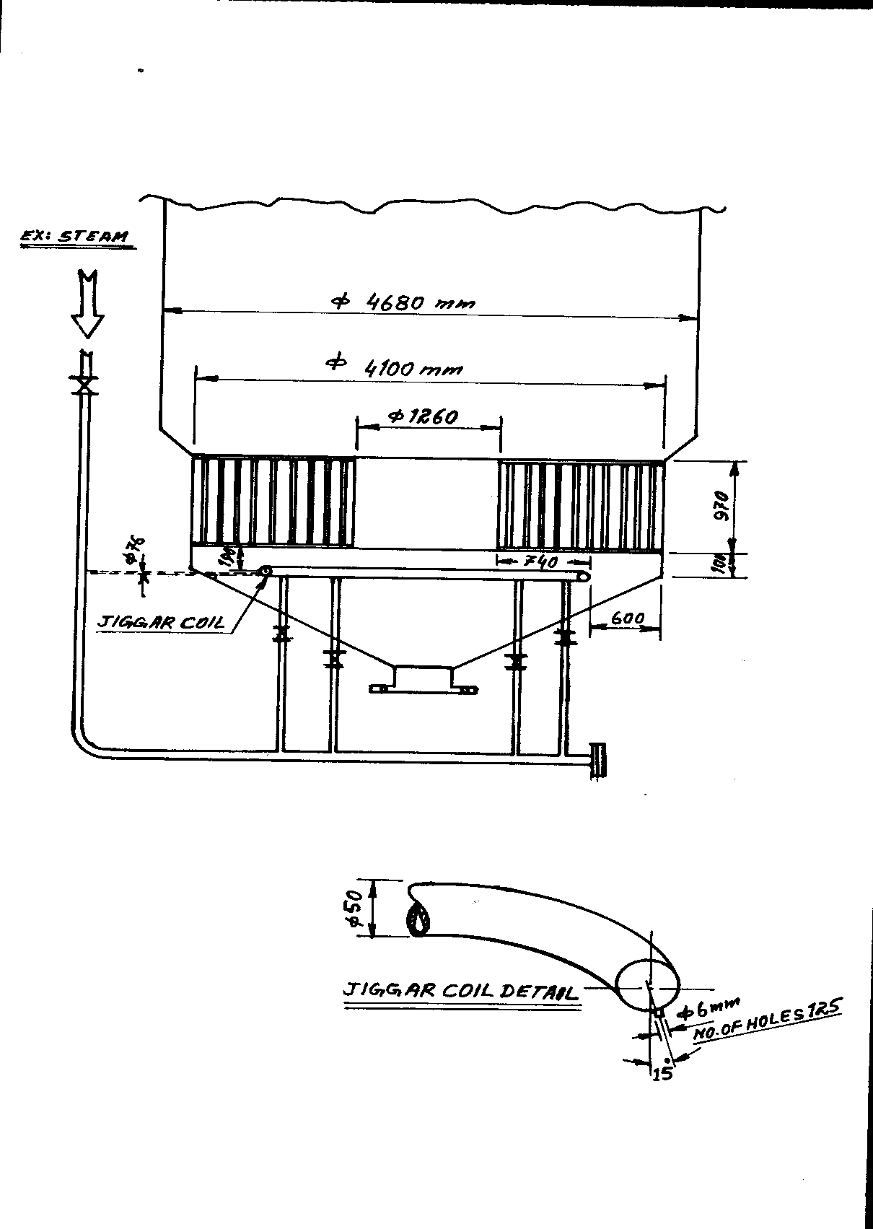

CFD results for vacuum pan assisted with & without jigger steam.

**Pan without Jigger Steam assistance.**

|  |  |
| --- | --- |
|  |  |

Pan with Jigger Steam assistance.

|  |  |
| --- | --- |
|  |  |

Stainless steel tubes drilled with Laser



Air test after 15,000 hrs operation



Following are the benefits of jigger steam in batch pan;

1. Improves circulation by 20%.
2. Improves heat transfer by 5-30%.
3. Shorter cycle time.
4. Reduced calandria steam pressure.
5. Applicable to both, batch & continuous pan.

**Automation:-**

Automation provides the best optimum control of any equipment process. Comparing to manual control, where performance fluctuates in between two extremes, i.e. optimums best control and worst control, due to the various reasons. Automation controls the equipment or process, to highest possible best control level. Following is the graph of manual and auto defecation juice p.H control of factory ‘A’.

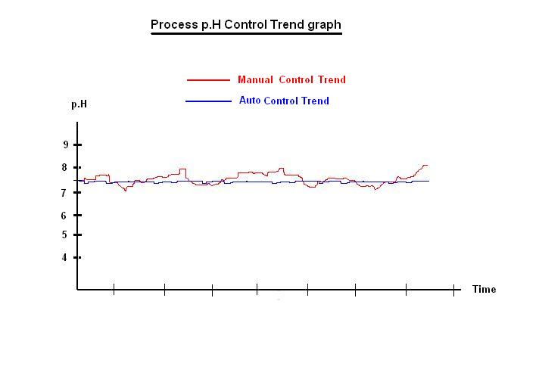

There are potential areas of process house, listed below, where automation plays important role for improving boiling house efficiency.

1. Juice heater temperature control automation.
2. Defecation pH control automation.
3. Juice clarifier polyelectrolyte dozing automation.
4. Evaporator automation.
5. Talo floc pH and temperature automation.
6. C-massecuite cooling & re-heating automation.
7. Conti & Batch pan automation.

We will discuss in detail automation of conti pan.

**Conti Pan Automation:**

Conti pan automation involves following loop control.

1. Vapour pressure control (Shell Vacuum)
2. Calandria vapor pressure control
3. Magma feed monitoring and control
4. Molasses feed monitoring and control.
5. Brix monitoring and control.
6. Condensate flow monitoring.
7. Jigger steam flow monitoring and control.

**Present Practice in Pakistan:**

In Pakistan, at present, most of the conti pans molasses feed is controlled by measuring and maintaining the brix of the massecuite for a fixed quantity of magma.

**Control Logic of Present system.**

1. Magma is not measured but controlled manually by adjusting the speed of magma metering pump by VFD.
2. No control of calandria steam pressure.
3. Molasses feed is without any measurement in 2 to 6 chambers to maintain any desired brix level.
4. No shell pressure control, however most of the mills have been using auto control condensers, which maintains the shell pressure with reasonable accuracy.
5. No condensate measurement & monitoring.
6. No Jigger steam control.

This system has many disadvantages, final massecuite purity and flow control is very poor, and this is due to the various reasons;

As the magma is fed manually without measuring its flow, however it is manually controlled by speed of metering pump through VFD but molasses flow is variable due to various reasons mentioned below, hence flow and purity of final masseciute exiting form pan fluctuate largely.

1. Brix of molasses feed; higher brix of inlet molasses means less flow of molasses and lower brix means higher flow of molasses to maintain desired brix.
2. If calandria pressure, which is uncontrolled, increases, it will evaporate more water which will result the higher feed of molasses and vice versa to maintain desired brix level.
3. If shell pressure is uncontrolled this will also affect evaporation and brix of masscuite and will affect the molasses feed. Lower vacuum means lower evaporation hence less molasses feed to maintain desired brix level and vice versa.

**Pan automation by mass flow controls.**

This system of control provides complete control and monitoring system based on mass flow. Hence a controlled final massecuite flow with target purity is achieved. The control logic is as follow.

1. Mass flow meter is installed at magma line, main molasses feed line, condensate line and water feed main line.
2. Brix probes are installed at all the 12 chambers of pan, main grain flow line and main molasses feed line, for on-line measurement.
3. Simple calculation program is incorporated in software designing to calculate the total solid flow of magma and molasses by inputting the purity of magma and molasses and from online brix of magma. Following will be the outcome;
4. Magma flow T/Hr
5. Molasses flow T/Hr
6. Solid in magma T/Hr
7. Water in magma T/Hr
8. Solid in molasses T/Hr
9. Water in molasses T/Hr
10. Sucrose in magma T/Hr
11. Sucrose in molasses T/Hr
12. Non sugar in magma T/Hr
13. Non sugar in molasses T/Hr
14. Solids in final massecuite T/Hr
15. Water in final massecuite T/Hr
16. For a given massecuite outflow of desired purity and brix the software calculates the required flow of magma, molasses and movement water addition.
17. Require magma flow is controlled by VFD of metering pump.
18. Required flow of molasses to desire chamber is controlled by operating on/off control valves of the chamber. It is important to introduce molasses to initial 1 to 9 chambers and rest of the 03 chambers on water feed for exhaustion of massecuite.
19. Molasses feed valves are provided at chamber 1 to 9.
20. Water addition valve are installed at the entire chambers to maintained brix of the chamber for proper exhaustion.
21. Total water evaporation is calculated by adding the water of magma +water molasses + movement water and subtracting it from the water in massecuite (Note: use refrectometer brix for calibration of brix probe). The input water is cross checked by totaling the output water of massecuite and condensate flow.
22. Calandria pressure is controlled to maintained required flow of movement water (“m” ratio for batch pan is 1.5 and for conti pan 1.2).
23. The Jigger steam quantity is measured by subtracting the total evaporation of pan from the total quantity of vapor condensed. ( As Jigger steam is not condensed in the pan and it vents as it is . however theoretically, a higher temperature Jigger steam, say 1st or 2nd vapor contributes in slight evaporation of water of materials but this is negligible and is not considered). Jigger steam, once measured, is then controlled by giving the ratio of total vapor condensed / total evaporation. This ratio varies between 1.1 to 1.5.

**The Benefit of mass flow base automation:**

1. Better control of final molasses brix and purity.
2. Minimum loss in molasses.
3. Improved sugar quality.
4. Steam economy.